Middle East Scavenger Hunt

***Use internet sources to answer these questions!! Be sure to write your answers in complete sentences. Please also list the websites you use to get these answers. Remember, GOOGLE is a search engine, not a SOURCE.***

1. How many countries are there in Southwest West?
2. Why is Southwest Asia called the Middle East?
3. What are the 3 Largest Middle Eastern countries (size)?
4. What are the 3 smallest (size) Middle Eastern countries?
5. How many bodies of water exist around and within the Middle East?
6. Name all the bodies of water that exist around and within the Middle East
7. What is climate like in the Middle East?
8. Are there any mountains or deserts that exist within the Middle East? What countries are they in?
9. Which Middle Eastern countries have the highest literacy rates? Which have the lowest?
10. What are ethnic groups?
11. What are the major (most dominant) ethnic groups that exist in the Middle East?
12. What are religious groups?
13. What are the major (most dominant) religious groups that exist in the Middle East?
14. What natural resources are popular in the Middle East?
15. Have there been any issues or fights in the Middle East because of Natural Resources?

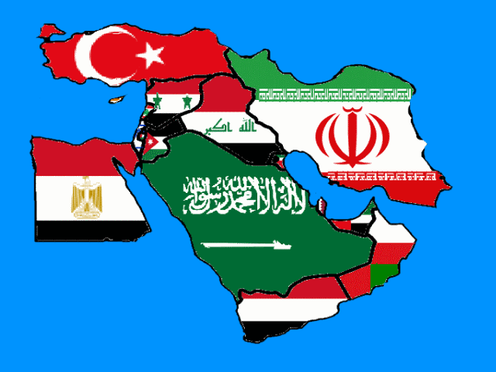

Journal Entry:If you lived in the Middle East, what country would you want to live in, why? Use the information that you have found to answer this question.